2020 Small Business Expos  Bring Voice To Your Business  Apply to Be on The Expos Soap Box | 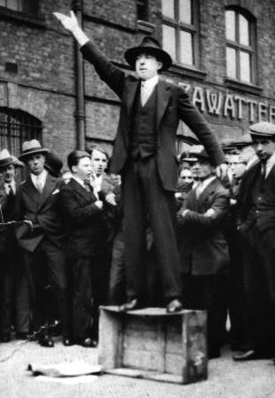
1. Please complete this simple Q&A
Why are you interested in being an expo soap box speaker?
What are some helpful tips or education you could share with the audience?
What will you be promoting on the expos soap box?
Anything you would like to share to support this application?

2. Choose the expo you’d like to apply
Brisbane Small Business Expo | Thursday 26th March 2020
_ | Business Soap Box Speaker Exhibitor | $1100
_ | Includes large exhibitor space - 3m x 3m (Limited Numbers) | NOW FULL
Redlands Coast Business Expo | Thursday 16 April 2020
_ | Business Soap Box Speaker Exhibitor | $1100
_ | Includes large exhibitor space - 3m x 3m (Limited Numbers)
Gold Coast Expo | Thursday 15th October 2020
_ | Business Soap Box Speaker Exhibitor | $1100
_ | Includes large exhibitor space - 3m x 3m (Limited Numbers)
If You Need Public Liability (PL) insurance, 1 day, per expo |  | $ 50
Your Totals (inc gst) |  | $
3. Complete the following information
Please read carefully and fill in the required fields. Thank you
Do you need power? YES/NO
Please advise if you large powered equipment.
Business Name
First / Last Name of Contact Person
Mobile / Land Line
Email Address
Postal Address
ABN
Products/Services promoting at the Expo | 1.  2.

4. Public liability insurance
Complete insurance details below, must be provided 1 WEEK PRIOR TO THE EXPO
If you don’t have PLI, no problem, we can put you on our policy for $50.
Name of insurer
Membership number
Insurance expiry

5. Marketing Investment
We process applications Thursday afternoons and Friday morning. We are open to payment plans, however all funds must be received within 6 weeks of the event you are speaking at.
Registration will only be processed once notified off approval as a Soap Box Speaker.
Date:
Name: | Surname:
Card No: | Expiry date: | CVC:
Amount Paid

6. Direct bank transfer
Please notify us by email when this has been attended to, so we can confirm receipt.
Account: Living with IT Pty Ltd (Small Business Expos Trading Account)
Bank: Commonwealth Bank
BSB: 064 474
Account: 1056 3931
7. Ready good person agreement
Date: / /
Full Name
(type name here)

Good person agreement
I/We abide by the set-up Terms and Conditions. (see appendix of T&Cs on next page). I/We will respect other exhibitors and guests and if we have any concerns will ask for help promptly and professionally. I/We will take care to stay safe when using stairs and getting in and around the expo for set up, engagement and pull down of our stands. I/We understand that dates and venues may change due to venue availability. I/We understand that it’s up to the expo team to secure our position on the day.

Cancellations and refunds
1. If you need to cancel your speaking spot email paulabrand@smallbusinessexpos.com.au
2. There are no refund is provided as a speaker as we do extensive marketing for you as a speaker.
You can transfer your table to a charity or another business and advise us of the replacement company – they must have their own insurance.
3. If you are unable to attend on the expo day due to unforeseen circumstances, you MUST
ring Paula 0475 411 793 or email paulabrand@smallbusinessexpos.com.au
to advise at the earliest possible time. No refund will be given.
4. If the organisers need to move the venue or date due to unforeseen circumstances –
we will provide you with ample notice of doing so. If you do not respond that you
cannot make it within 6 weeks prior to the new date, no refund is provided.
By you and your company (if applicable) signing agreement to these terms and conditions
5. Transfers to other Expo events are no allowed
6. If you are unable to attend the Expo, it is your responsibility to on sell the stand.
7 Cash bookings cannot be transferred into Bartercard bookings at a later date.

